The World Report

Mikaela Pisani, Marcin Grzechowiak, Jereamy Riggs, Roger Valdez

**Multivariate Analysis**

# 

# 

# 

# 

# I. Introduction

The World Report aims to profile countries based on information relating to economic, social, financial, and technological factors.

**Dataset:**

The dataset is used from GapMinder World, which contains data from several sources. It presents economic, social, financial and technological indicators about countries. The variables considered for this study are Population Total, Murder Total, Armed Forces Personnel Total, Cell Phones per 100 People, Fertility Rate Total, Urban Population, Suicide Total, Life Expectancy, Corruption Perception Index, Internet Users (% of Population), Child Mortality, Income Per Person, Sex Ratio, Investment (as % of GDP) and Inequality Index(GINI). For more information about the indicators see the appendix of the report. All indicator values come from the year 2016. The only exception to this is Sex Ratio. It is assumed that the sex ratio did not change significantly between 2015 and 2016 and using data from 2015 is a good approximation of the year 2016 (Table 1 and Table 2 in Appendix).

**Motivation:**

The motivation is focused on comparing countries from the economic, social, and government perspectives. This study can be useful for instance, for a person that wants to move to another country, it might be important to consider these aspects to make the decision. In addition, it could be useful for the World Health Organization when determining which countries it should support in each field. Finally, firms that want to open an office in another country might be interested in this data as careful considerations are made when making such a large business decision.

**Scholarly Citations:**

One of the perspectives of the project is that of a business looking to expand infrastructure by investigating factors for potential new locations in different countries. The article, “Factors affecting location decisions in international operations – a Delphi study” focuses on factors that guide firms to choose locations while opening a branch in a new country. The factors in this report can be considered in future decision making when firms are looking to expand into different countries.

On the other hand, country profiling might be useful to recognize places where global health resources are needed the most. The study “Financing of global health: tracking development assistance for health from 1990 to 2007,” based their findings on factors that included income, HIV/AIDS, and other diseases. The factors presented here may be considered as complementary factors when the World Health Organization is deciding which countries to fund.As a result, ‘The World Report’ might be useful in both mentioned contexts.

# II. Data Cleaning and Outlier Visualization

It is important to acknowledge the missing values in the dataset in order to perform accurate calculations. In the case of visualization, the ability to view the outliers gives the opportunity to account for their presence and to decide if removal is necessary.

The first step was importing the data from multiple csv files and merging the columns on a single column that each file shared, the country column. Once the merging process was complete, a function was found that would divide the countries by the continent they belonged to in order to create a new column called “continent.” Unfortunately, the function did not divide the Americas into North, South, and Central so a *for loop* was created to iterate through the countries column in order to place them into a more specific part of the Americas. The reason for the new column “continent” was to account for missing values in the data. If an NA value was spotted it would insert the median value depending on the continent associated with the country that had the missing value. Since outliers have less of an effect on the median, it was chosen as the replacement for the NA values, rather than the mean.

Outliers are present in the data and boxplots were created in order to visualize which countries were outliers according to the indicator. Outliers were not removed because in this case the outlier values were not the results of an error, but instead were actual data points. If the outliers were removed, the potential to lose meaning and value from the data would increase greatly. The reason is an outlier would be associated with a country and in order to remove the outlier we would have to delete an entire row. It is believe that those ‘outliers’ in our data in fact store very important information and should not be removed.

In order to get insights about outliers, three columns were presented on boxplots below (Figure 1). Please find all boxplots for each column in the Appendix.

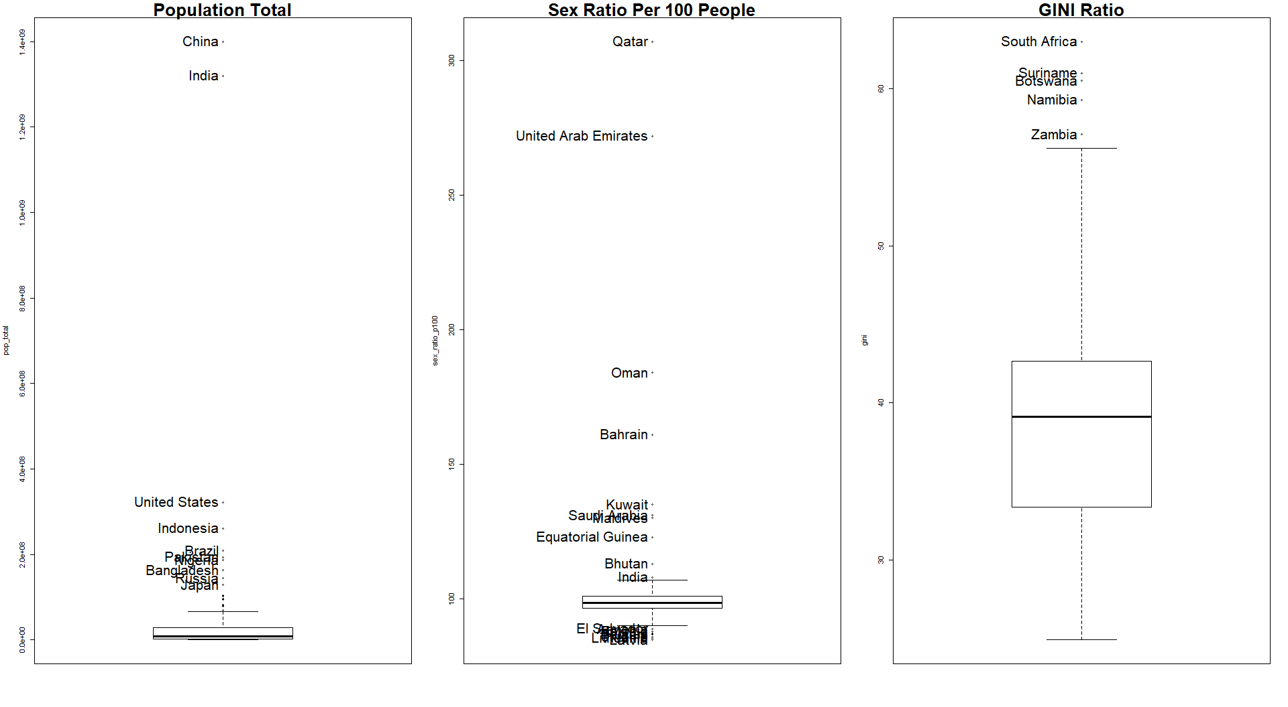

*Figure 1. Example of outliers in the data. All graphs are available in the Appendix.*

# III. Dimension Reduction Analysis

The data set contains 17 variables. In order to easily present them in a 2 or 3-dimensional plot, dimension reduction analyses were computed. Two techniques were used: Multidimensional Scaling (MDS) and Principal Component Analysis (PCA).

## a. Multidimensional Scaling (MDS)

In order to provide a general insight into the data, all countries were presented in 3-dimensional space. At first glance, clusters between continents can be observed. Countries which belong to the same continent present a similar profile. The most diverse continent is Asia with many outliers. Countries in Asia spread from Europe (the one end) to Africa (the second end). It can be seen that North America and South America are similar to each other (Figure 2).



*Figure 2. Continents presented in 3D space. (If not displayed correctly, please see a .gif here:* [*https://bit.ly/2ZM4tKY*](https://bit.ly/2ZM4tKY)*)*

## b. Principal Components Analysis (PCA)

The Principal Component Analysis (PCA) was used in order to provide more insights into the data and visualize it in two-dimensional plots. Three principal components were presented on the plots below and their cumulative proportion of variance is equal to 74%.

Interpretation of PC1, PC2, and PC3 is as follows:

**PC1:** is highly loaded in variables such as number of phones, life expectancy, corruption index, access to the internet and income.

**PC2:** is highly loaded in the number of suicides and sex ratio.

**PC3:** is especially meaningful in the context of inequality.

More information about components can be found in Figure 1 below.

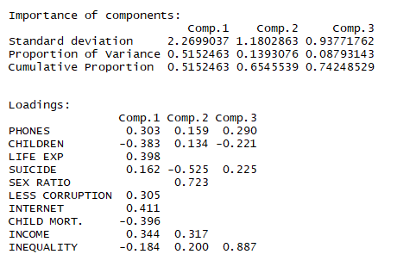

*Figure 3. Summary Result for the first three Principal Components*

In order to present the PCA results, two graphs are displayed below. Ellipses were added to the graphs to better showcase the concentration(s) of points. The size of each ellipse is largely influenced by outliers present within the data. For an example of this, observe the ellipse for the continent of Asia. There are outliers like Qatar and United Arab Emirates that cause the ellipse to be broadened.

**Plot PC1 vs PC2**

On the right of the plot with a high value of PC1, are what we consider highly-developed countries (Figure 4). Both Europe and North America can be spotted here. Those continents are above the average in the context of less corruption, life expectancy, internet access, number of phones and income per person.

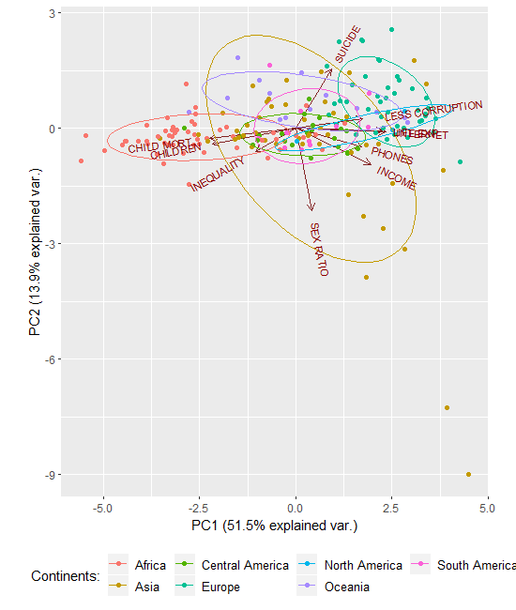

Figure 4. Relation between PC1 and PC2.

On the left side of the plot, with a low value of PC1 are the countries that are less developed. As somewhat expected, Africa can be spotted here. Those countries are above the average in the context of high child mortality, number of children per woman and inequality.

An interesting phenomenon can be seen when looking at Asia. The continent is the most diverse among all others in both directions for PC1 and PC2. Some countries in Asia are highly developed while others are rather poor (PC1). Think about the stark contrast between the economies of Afghanistan, Yemen, Nepal and those of China, Qatar, and Singapore. This helps create an image of how different the countries are within Asia as a whole. Within the context of PC2, some countries have an ‘extreme’ value for sex ratio (men outnumber women significantly). The same countries that were mentioned to influence the concentration ellipses, Qatar and the UAE, are excellent examples of countries where the population of men vastly outweighs that of the women. This example proofs how important roles play outliers in this report. If those data were deleted at the beginning, we would lose those information.

PC1 and PC2 do not provide many insights into Central America nor South America, since values for these continents are centered around the average or can be found in the middle of the plot.

**Plot PC1 vs PC3**

The second plot shows that very high inequality exists especially in South America and Africa (Figure 5). The below plots show also that there is a high correlation between variables: number of phones, less corruption, internet access, and income. An additional group of highly correlated variables are child mortality and number of children per woman.

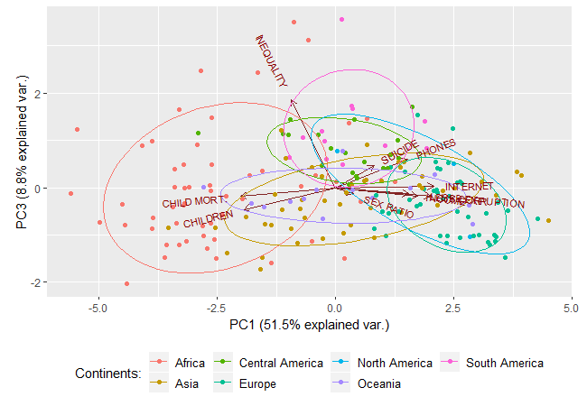

Figure 5. Relation between PC3 and PC1.

**PCA on the World Map**

In order to show which countries are the highest in each principal component, a World Map is presented. From each component (PC1, PC2, and PC3) the top 15 countries with the highest loadings in each of the group were chosen and plotted on the map (Figure 6). Please be aware that some highlighted countries are difficult to see as they are geographically small.

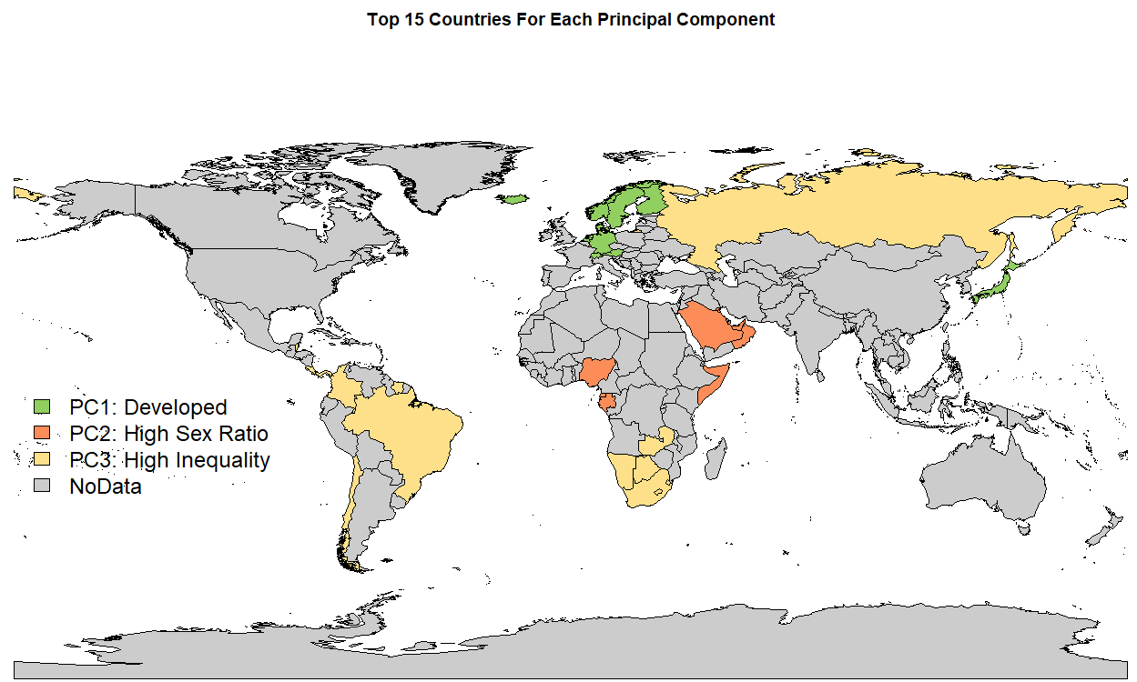

*Figure 6. PCA results presented on the world map.*

It can be seen that among highly-developed countries are Scandinavian Countries. High sex ratio index is presented in the Middle East and Africa, while countries with high inequality are for instance, South Africa, Brazil and Russia.

Note: from the analysis, columns such as population total, number of murders, number of armed forces, urban population total and percentage of investments were excluded. These variables had a low correlation with the rest of the columns and much more dimensions would be needed to explain the data. As such in order to clearly explain the relation in data more dimension would need to be used, what would prevent to present variables on the two-dimensional plots.

# IV. Cluster Analysis

For Cluster Analysis, the goal was to discover groups or clusters of observations that are homogeneous and separated from other groups. Three clustering methods were performed; Hierarchical, K-Means, and Model-Based. A comparison of the RMSE between each model proves useful for determining which is best described by the original data.

### a. Hierarchical Clustering between Continents

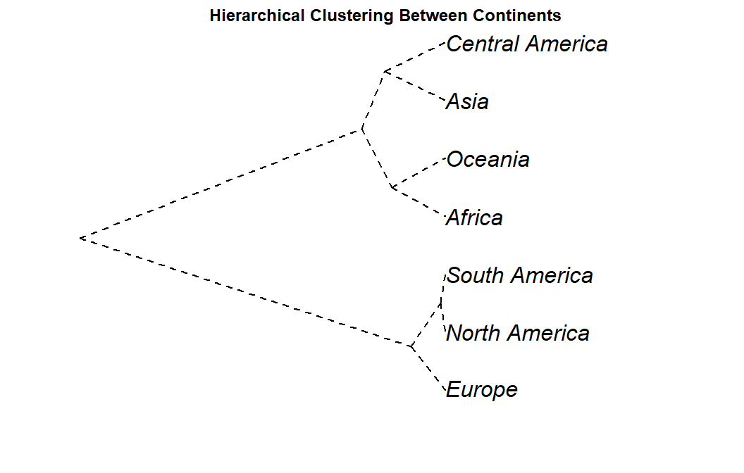At the very beginning the cluster between continents were computed in order to grasp a big picture of the relation between the data. The hierarchical model below explains that the data has two main clusters (Figure 7). The first cluster includes Africa, Oceania, Asia, and Central America while the second includes South America, Europe, and North America. The interesting thing is that Africa is clustered with Oceania which includes Australia and New Zealand. The reason this is interesting is the fact that Australia and New Zealand are considered highly developed, but they are grouped with the entire African continent. This is more than likely due to the reason that Oceania also has many small islands included in the continent that are not as developed which causes the grouping with Africa.

*Figure 7. Hierarchical Clusters among columns*

# b. K-means and Model-Based clustering between Countries

In order to group countries two techniques were used and compared: K-means and Model-Based algorithm. In the case of K-means a scree plot suggests number of groups between 6 and 7. It is believed that 6 is an appropriate number, while with 7 groups very little groups are created (one group consists only 2 countries and the second 4). The plot of K-means result is presented below (Figure 8).

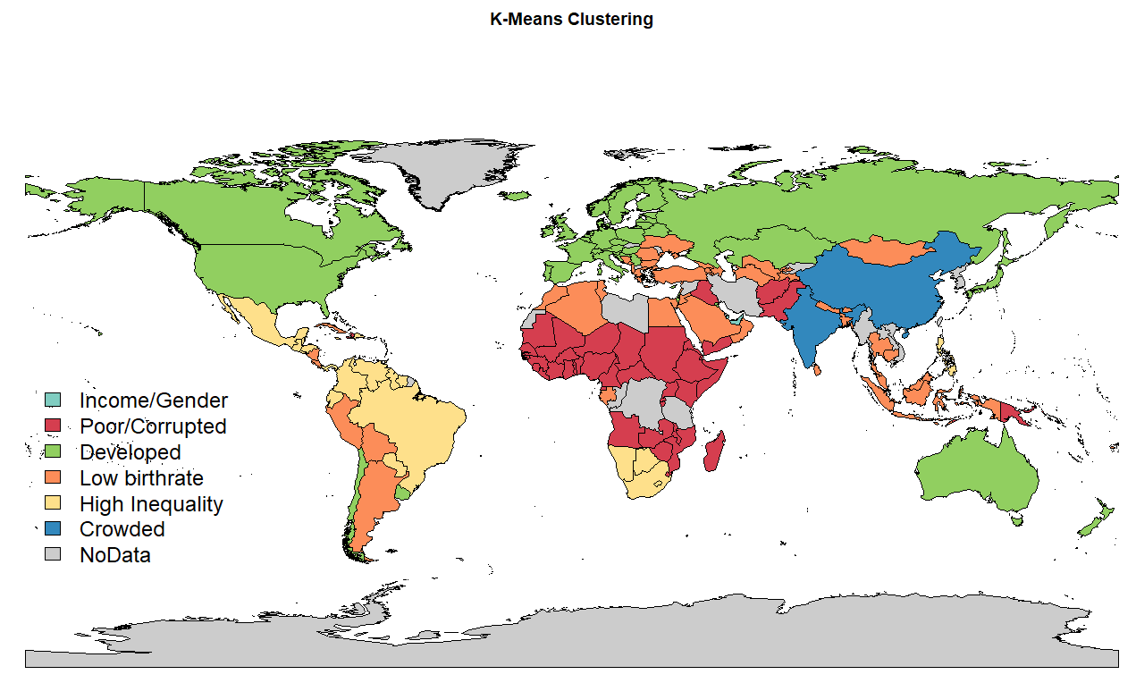

Figure 8. Result of K-means Clustering presented on the map.

The second clusters are based on Model-Based method. It was allowed to let the algorithm choose the amount of groups automatically, as such 7 groups were created (Figure 9).

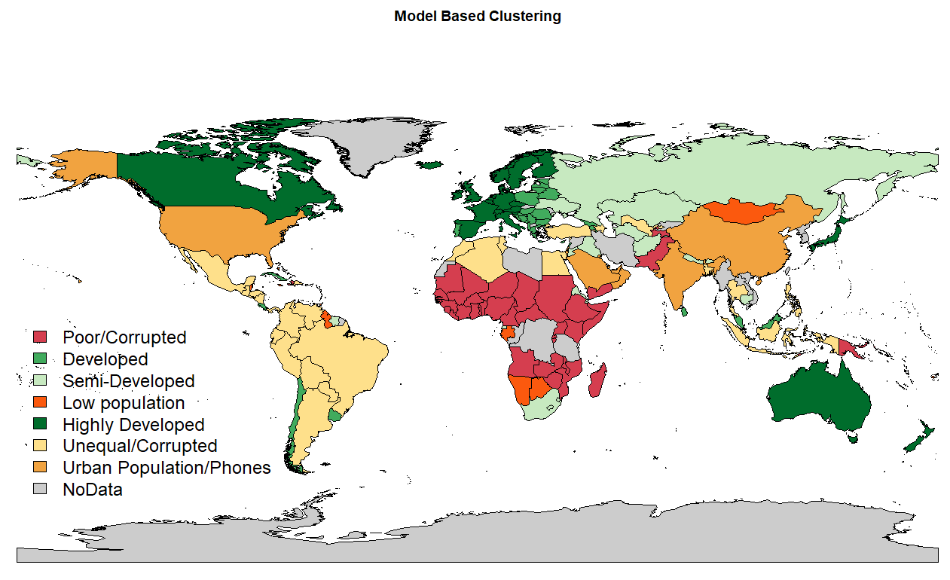

Figure 9. Result of Model-Based Clustering presented on the map.

Group 7 (Urban Population/ Phones) from the Model-based method proved difficult to interpret as the results for this group were all over the place. The population total, sex ratio, income per person, number of phones per 100 people were all very significant yet the countries that belonged to this given grouping did not possess above average values for all of these categories. For example, Qatar has one of the highest sex ratios and income per person values yet has a significantly lower population total therefore grouping it with a country like China which has a very large population and a lower income per person did not make sense. For this reason, it was concluded that group 7 was ‘lost in the translation’ between the K-means and Model-based methods. Interpretation of group 7 did not seem like it had a definite answer.

Additionally, the developed countries that were observed in the K-means model were split into three separate groups under the Model-based method, appropriately labeled semi-developed, developed, and highly-developed. Highly-developed countries were those that had high principal component 1 loading values. Again, this component was loaded on characteristics like low child mortality, high income, high number of phones per person, and low inequality. The two other groupings involving developed countries were also loaded on these same variables, give or take one or two, however the degree to which they were loaded was less. As such, the interpretation for these groups suggested making tiers out of the development characteristic.

The poorer, less-developed countries like those found in Africa remained consistent between the two clustering techniques. The Model-based clusters of Europe showed an interesting characteristic that as you moved East, the level of development in the countries decreased. So, Western Europe was more developed than Eastern Europe which was more developed than the Western parts of Russia.

Additionally, a comparison of the chi-squared test was performed to determine if a dependency between groups and continents existed. The results suggest that Model-based groups are more similar to continents. The chi-squared test is significant in both methods indicating dependency between the groups and continents. However, for K-Means method, X-squared is equal to 233.35, while for Model-Based method, X-squared is equal to 313.22.

# V. Exploratory Factor Analysis

Exploratory Factor Analysis looks to link observable variables to unobservable variables via regression modeling. The discovery of the relationship(s) between variables without making any assumptions that such relationships may exist is crucial when defining what factors, and how many, may best describe the data.

In order to find the number of factors, EFA was performed starting with 1 factor, increasing the number of factors until getting a value for RMSE lower than 0.05. It was concluded that the optimal number of factors is four with an RMSE value of 0.05. Performing EFA with 4 factors, the loadings are:

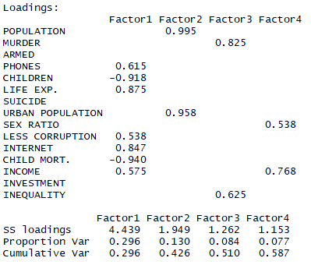

Figure 10. Result of the EFA (loadings).

From the loadings it can be interpreted:

**Factor 1** has high life expectancy, internet access, balanced income per person, it is low in child mortality and children per woman. For these reasons, Factor 1 is believed to represent the level of development of the country.   
**Factor 2** represents the level of population for the countries because of the high loading in Population total and Urban population total.   
**Factor 3** represents the inequality (represented by GINI index) and murder rates for the countries.   
**Factor 4** represents the level of income related with the amount of men and women that the country has.

In order to visualize these four factors graphically, the scores of the top 10 were taken which allowed for the creation of four groups. Each group is a depiction of the factor with the most relevance, so for example group 1 was high in factor 1 which indicated developed countries.

The groups of countries are named as follows:   
Factor 1: Developed   
Factor 2: Crowed   
Factor 3: Inequality   
Factor 4: Gender/Income   
These can be visualized in the following graph below (Figure 11).

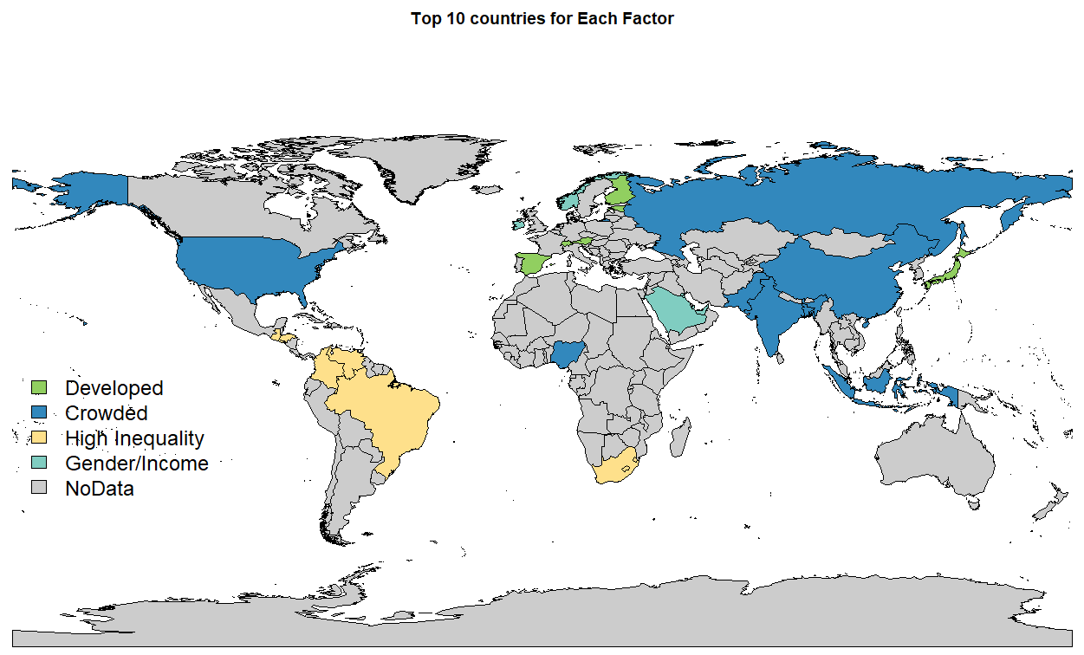

Figure 11. Result of the EFA presented on the Map..

Note: There are some countries such as Singapore or Qatar that are in the groups but are too small to show in the map.

The countries in group 1 are: Spain, Estonia, Finland, Switzerland, Andorra, Austria, Singapore, Liechtenstein, South Korea and Japan. Note: Japan is in group 1 and group 2, however, it is larger in group 1 so its colored accordingly.

The countries in group 2 are: Japan, Russia, Bangladesh, Pakistan, Nigeria, Brazil, Indonesia, United States, India, China.

The countries in group 3 are: Brunei Darussalam, Swaziland, Honduras, Brazil, Guatemala, Colombia, Venezuela, Lesotho, South Africa, El Salvador.

The countries in group 4 are: Saudi Arabia, Monaco, Norway, Ireland, Kuwait, Brunei, Singapore, United Arab Emirates, Luxembourg, Qatar.

# VI. Confirmatory Factor Analysis

CFA was performed with the intent of validating the EFA model in section V. After many tries of performing CFA, using different approaches and libraries, the result could not be computed. Several different errors were produced.

During the first method the ‘sem’ library was used with 4 factors, however within the result, the following error was displayed: *“Iteration limit exceeded. Algorithm failed”.* This means that the algorithm did not converge after 1000 iterations.

The second attempt used the ‘lavaan’ library, again with the 4 factors. In this case, the following error was received: *“ lavaan WARNING: some observed variances are (at least) a factor 1000 times larger than others”*

Using the method ‘varTable(fit)’ to investigate the problem, it could be seen that the variances for the variables were very high. It was decided that scaling the data might solve this issue. After using the function ‘scale’ based on z-score, the model did not find a solution, showing the following error: “*lavaan WARNING: the optimizer warns that a solution has NOT been found”.* When the log function was used to scale the data, the same error was found.

Another attempt was made where the EFA was remodeled, removing the variables that had a low correlation in the dataset. This new EFA model produced 3 factors with an RMSE of 0.029. Performing CFA with these 3 factors, the error *“Negative parameter variances”* was found. When the “lavaan” library was instead, the error *“lavaan WARNING: some observed variances are larger than 1000000”* was received. Then, it was decided to perform the model with the log of the data. But this attempt did find a solution.

Finally, it was decided to reduce number of factors to 2 and check if the algorithm would converge. When performing EFA with 2 factors the RMSE obtained was 0.058, which is greater than 0.05. It is understood that an RMSE below 0.05 is ideal, however it was used to check if the model would converge or produce no errors. Performing CFA with the factors obtained in this case worked however it is not the model of the true factors.

The results of the CFA model with 2 factors are provided below. It can be seen that p-value is very low, which means that data does not support the model. Although SRMR is good, GFI and AGFI are not large enough.

*Model Chi-square = 131.3475 Df = 19 Pr(>Chisq) = 8.101801e-19 ;   
Goodness-of-fit index = 0.8387516;   
Adjusted goodness-of-fit index = 0.6944767;   
SRMR = 0.05365541*

It is believed that the EFA model from part V is the best fit of data, but it could not be confirmed because of the received errors. The second EFA model, that was based on a smaller number of variables and produced 2 factors, was used to perform a new CFA. This approach was taken to check if the error(s) with a smaller number of factors would still occur. It was thought that reducing the number of variables would lead to a smaller number of factors needed to model the data, leading to less iterations performed. Thus, in order to reduce the number of iterations and in order to perform calculations, variables with low correlation were deleted. Despite the results computed with the CFA model, it is believed that it is not the best approach as a model with 4 factors would be.

# VII. Conclusion

Because of the big differences between countries dataset contains many outliers which might affect some of the result of analysis. However, if outliers were deleted, the analysis would not have made sense because it is believed that those outliers present meaningful information. Most of the analysis confirms what we know about countries and continents, however, some analysis provided very interesting information. One interesting result is that Oceania, which included well developed countries such as Australia and New Zealand, were classified in the same group as Africa. It might be assumed that small islands in Oceania pull down the entire continent to a level similar to that of Africa. Another interesting result comes from comparing two grouping methods between each other: K-means and Model-Based method. The latter distinguishes developed countries more precisely and divides them into three groups, while K-means group developed countries into only one category.

The project was based on different indicators pulled from the GapMinder website. In order to improve analysis more economical, social, financial and technological factors might be added to the models presented in the report in order to profile countries more precisely. The project is available online, in order to contribute in the further analysis please visit: <https://github.com/grzechowiak/Multivariate-Analysis-Project>.

Because of receiving many errors in part VI (CFA), defined factors in EFA could not be confirmed. Further studies could be done in order to confirm chosen latent variables in the report.

Based on the findings in ‘The World Report’ the World Health Organization might look towards Oceania to provide aid due to the grouping on the same level as Africa. From the business as well as personal perspective, the best place for a living location in a new country would be in Western Europe and Scandinavia due to the high development.

# VIII. Appendix

Table 1. Indicator used in the analysis and their source.

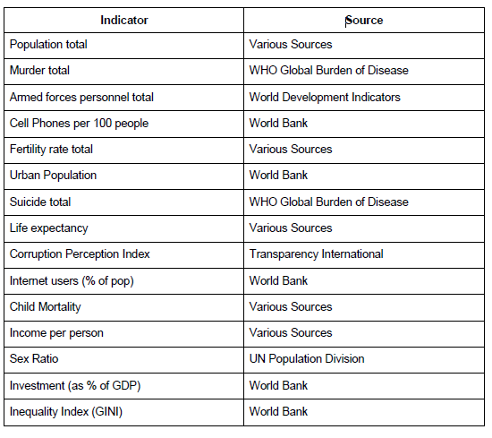

Table 2. Explanation of factors used in analysis.

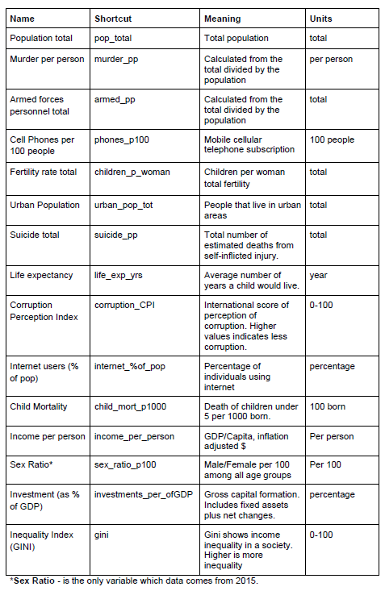

Table 3. All data presented on the boxplots.

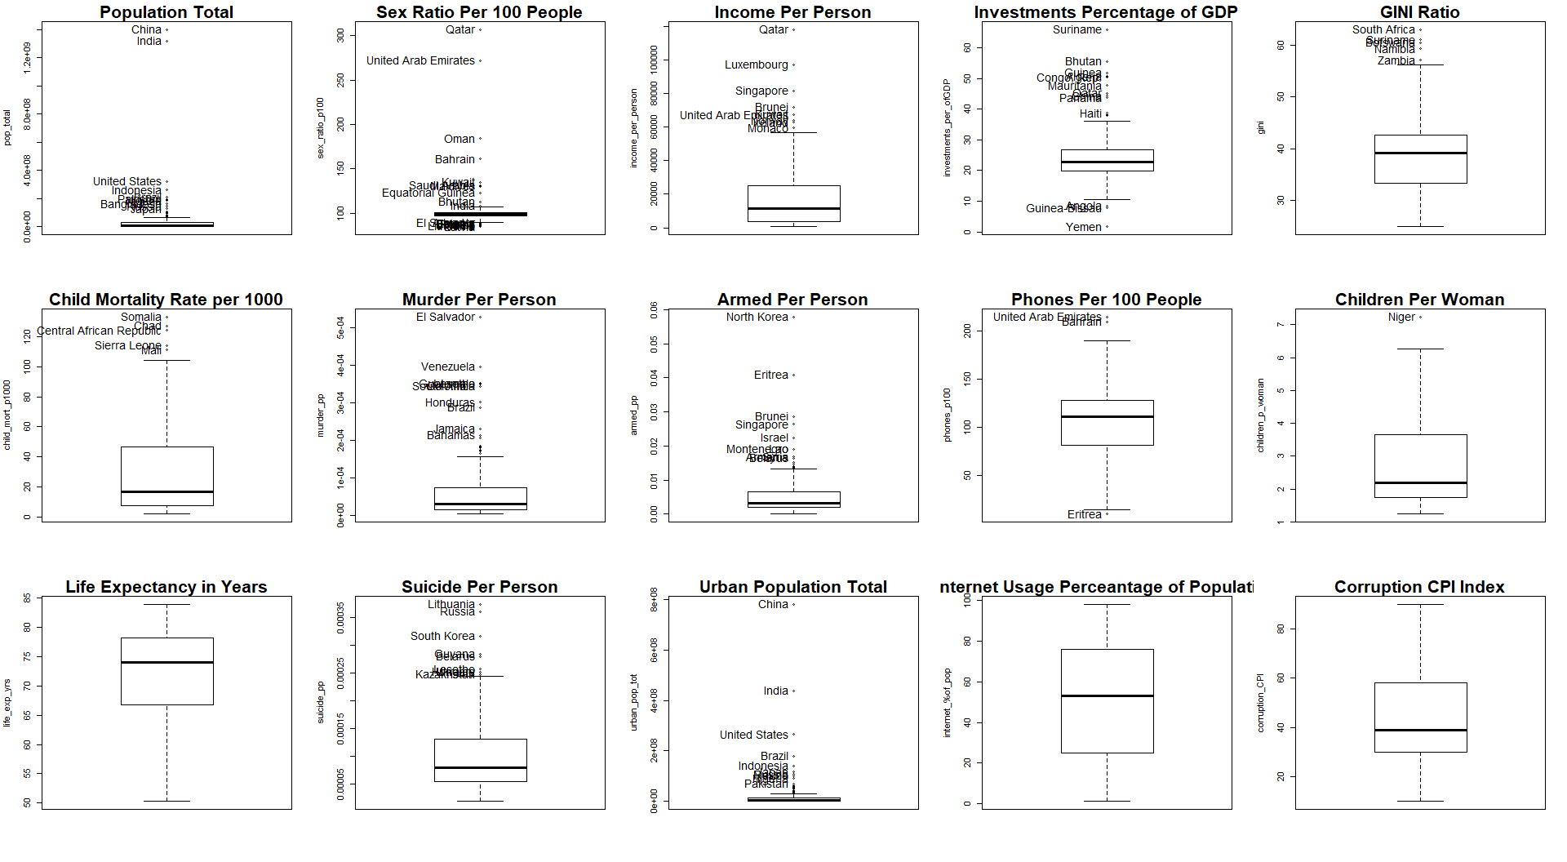

Note: please zoom in the plot in order to investigate outliers.

# IX. References

B.L. MacCarthy, W. Atthirawong, (2003) ["Factors affecting location decisions in international operations – a Delphi study"](https://www.emeraldinsight.com/doi/abs/10.1108/01443570310481568), International Journal of Operations & Production Management, Vol. 23 Issue: 7, pp.794-818, <https://doi.org/10.1108/01443570310481568>

Nirmala Ravishankar,Paul Gubbins,Rebecca J Cooley,Katherine Leach-Kemon,Catherine M Michaud,Dean T Jamison,Christopher JL Murray, (2009) “Financing of global health: tracking development assistance for health from 1990 to 2007”, The Lancet, Vol. 373: Issue: 9681, pp. 2113-2124, https://www.sciencedirect.com/science/article/pii/S0140673609608813